**Points for Innovations:**

1. Rather than generating uniformly distributed points in pixels, perform importance sampling by generating rays with a weighted distribution, starting from a cosine-weighted distribution, and averaging the unweighted radiance value(for more vivid vision, this simplification needs more complicated computation, to do…).

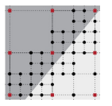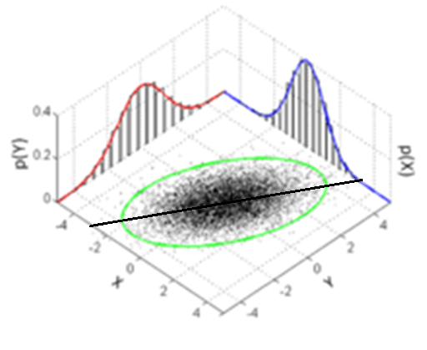

1. **Quick exit sampling loop** during AreaReSTIR sampling, if find big difference among samples, which mean an edge in current pixel. In order to find edge quickly, samples in subareas firstly, if all those samples from different subareas are similar or same, that means the current pixel is smooth. We don’t need to sample at subpixel points, sample at center of pixel is good enough.
   1. **Sample at subareas**
   2. **Samples are same/very similar, sample at center and quit**
   3. **Samples with difference, cluster them to determine the edge**
   4. **Sample along the edge for integral.**
2. Including more history information from previous frames, from only the last frame to the last 4 frames, there are more history samples in the current reservoir for selection.

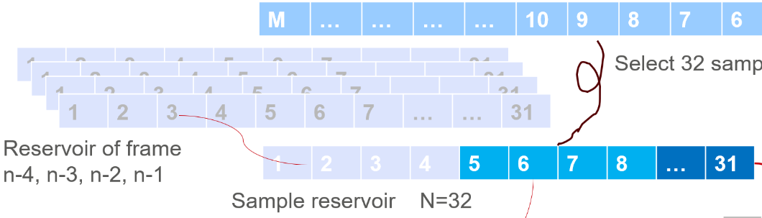

1. Starting to sample from a lower resolution, ½ resolution means 4 frames are needed to combine into one frame. After the first 4 frames, each next frame can borrow samples from 4 previous frames, not only from the last frame.

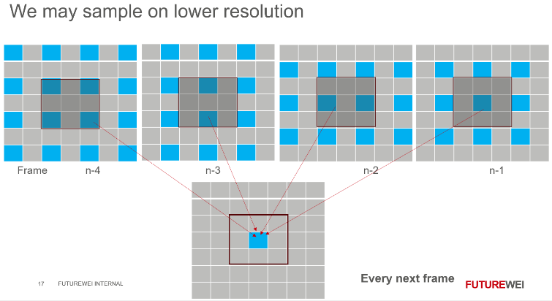

1. From 1 spp to 1.x spp, adaptive select one sample for rendering, or pass rendering by copying/averaging colors from neighboring pixels when in a smooth area. We can also extend our research on ReSTIR rendering from 1spp to 2 or more spp

 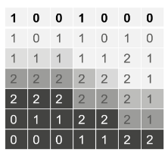

1. **Share radiance** with neighboring pixels by spreading, radiance from a ray is not a point, but a PSF

